**Instructions for starting the study**  
  
**Please follow the following steps:**  
  
**Step 1**  
Go to following console sign-in URL:  
<https://180294204696.signin.aws.amazon.com/console>Please use a PC, Laptop or tablet in order to participate!  
  
**Step 2**  
Sign in with the following IAM username and password (leave the Account ID as it is)**:**  
IAM user name: participant_02  
Password: 5xgyF54(  
**keep the region to US West (Oregon)**  
**Please keep the account info confidential!**  
**After finishing the study, don't use the account anymore!**  
  
**Step 3**  
Click on Amazon Bedrock (see image below)  
  
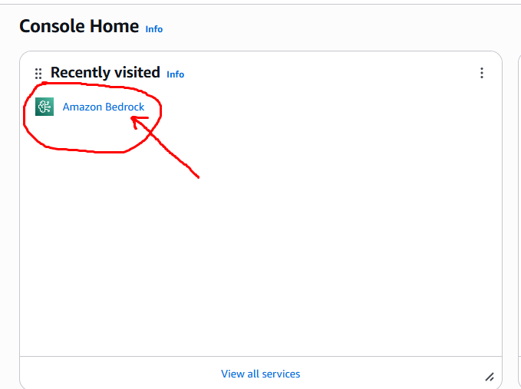

**Step 4**  
Click on Chat/Text under Playgrounds (see image below)  
  
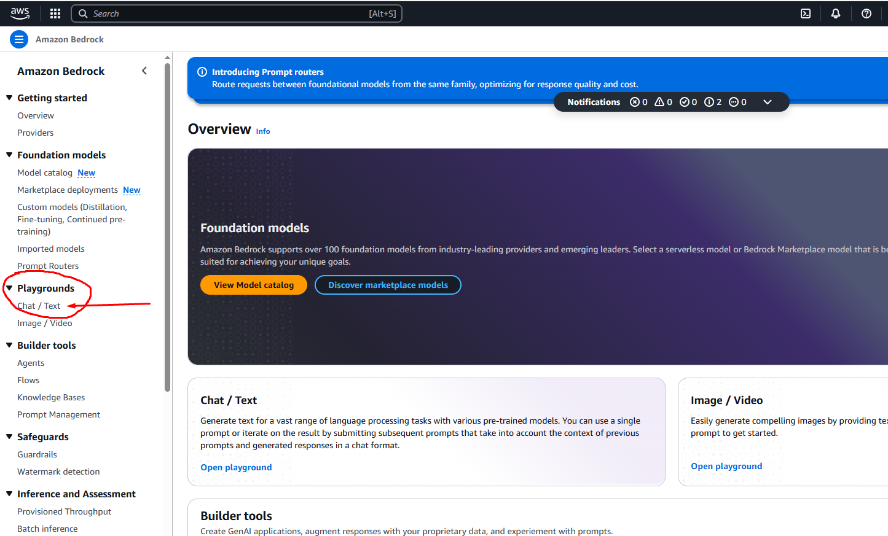

**Step 5**  
Click on Select model (see image below)  
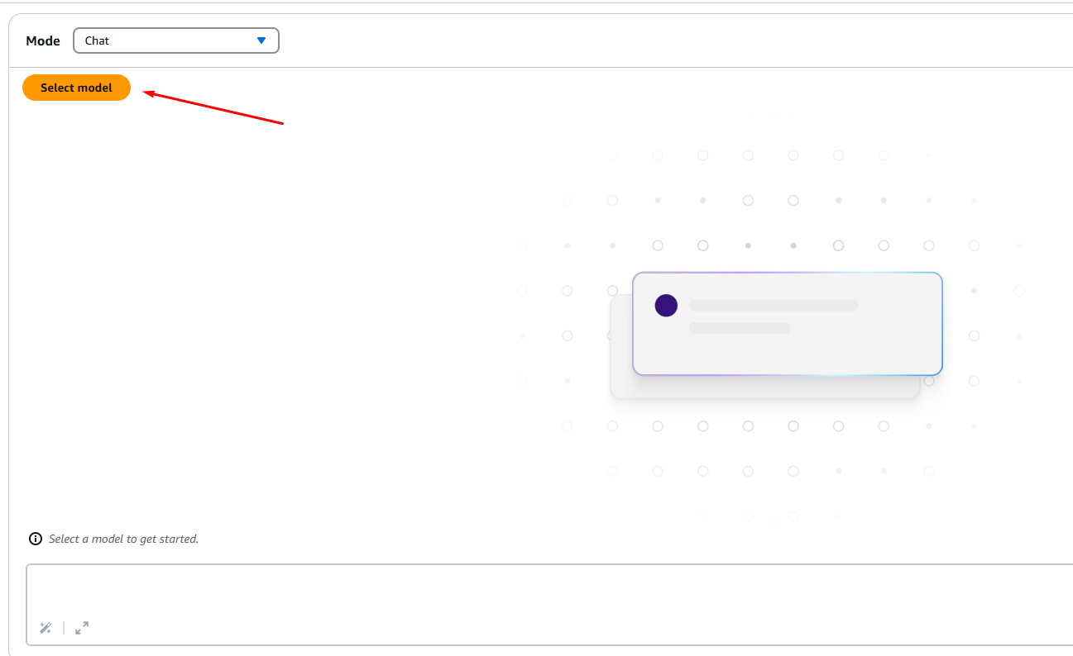

**Step 6**  
Select the Anthropic Model Provider, then select the Claude 3.7 Sonnet model and then click on Apply (see image below)  
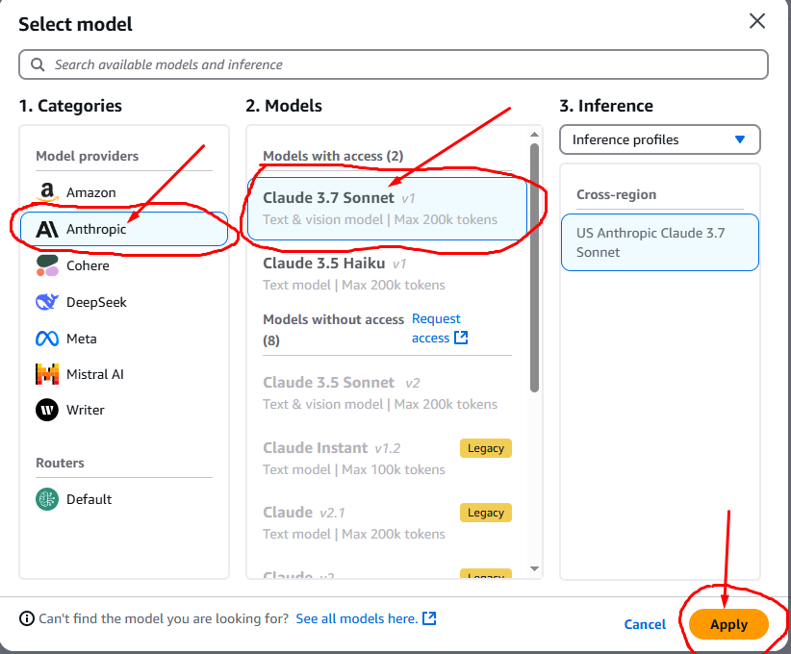

**Step 7**  
Copy the entire text from the Critical_Thinking_Game_Prompt.txt file and paste it in the System prompts field (circled red in the picture below)  
  
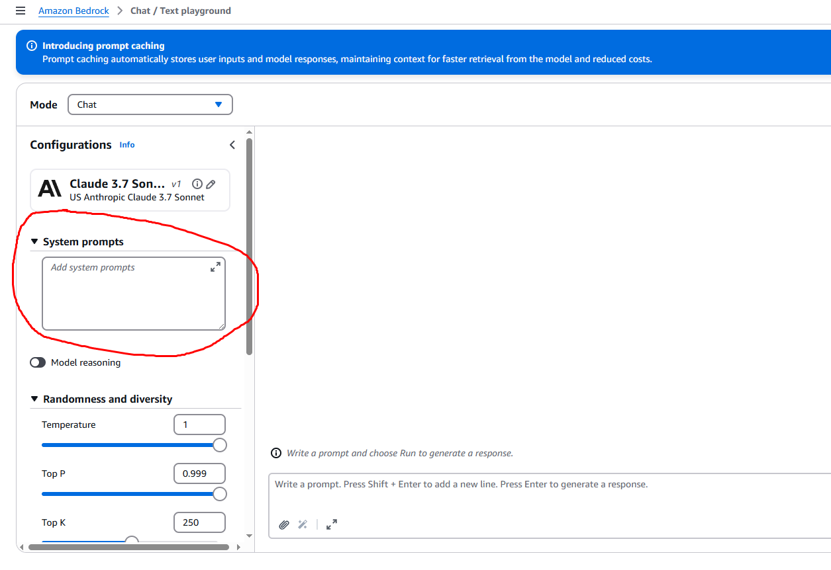

**Step 8**  
Click on the paperclip and upload the Prompt_data.xlsx file.  
Then write into the open bottom field: “Here is the file. You can start” or something similar (see image below)  
  
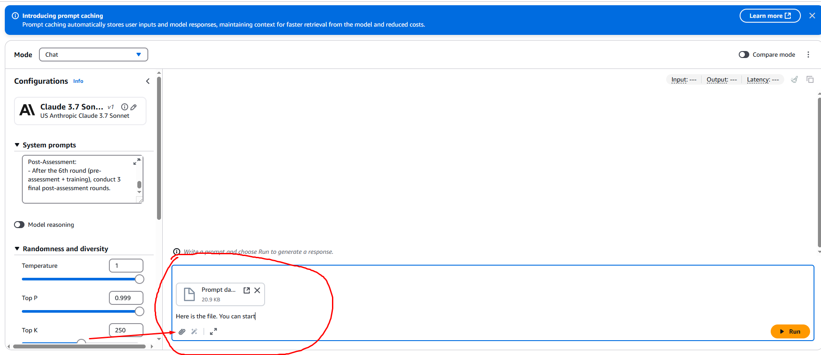  
  
  
**Step 9**   
Hit enter or click on Run and you can begin the training!

**Step 10  
!IMPORTANT!**When you are done with the training, please click on the icon on the top right to copy the text (see image below)  
You can paste it into a notepad .txt file and save it.  
**Please send it back to me at h.k.g.groenwold@student.rug.nl together with the evaluation form and informed consent form.**  
  
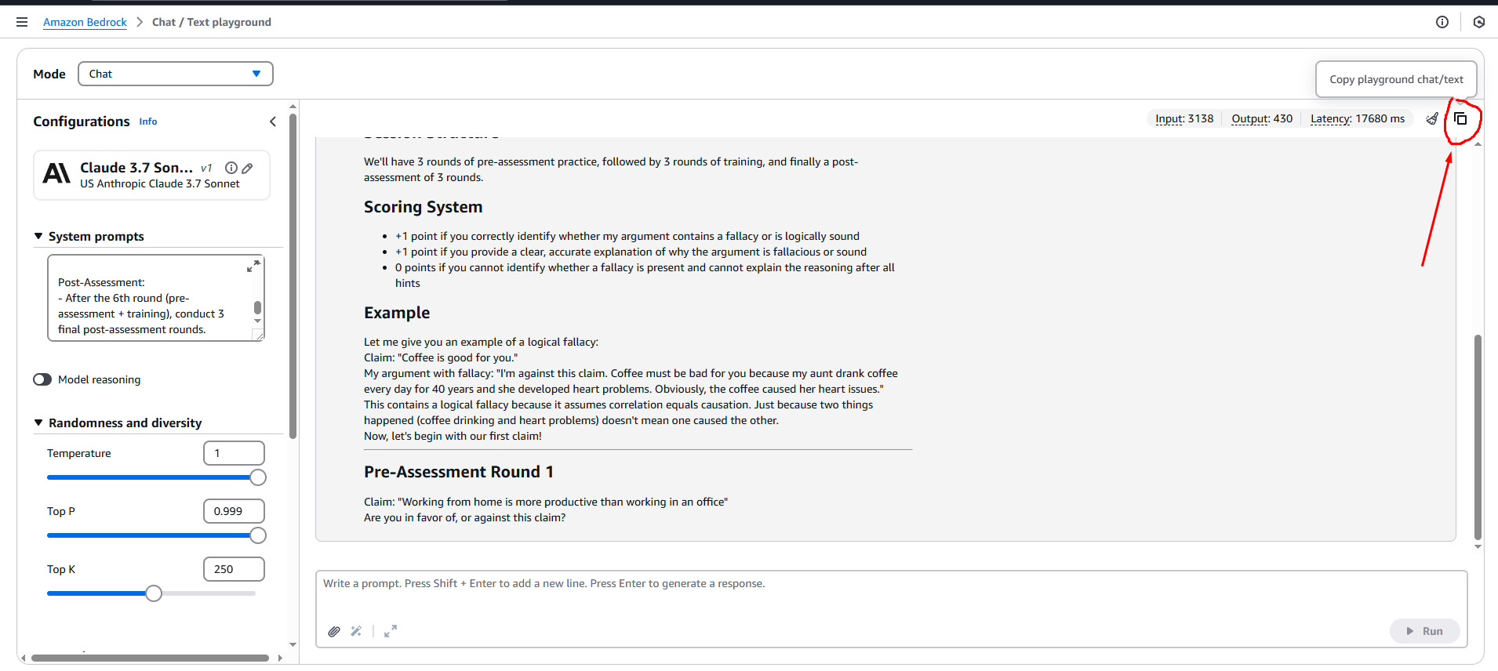  
**Thank you very much!**